Report form for late reported test results

The sample is a necklace and can be divided into different parts:

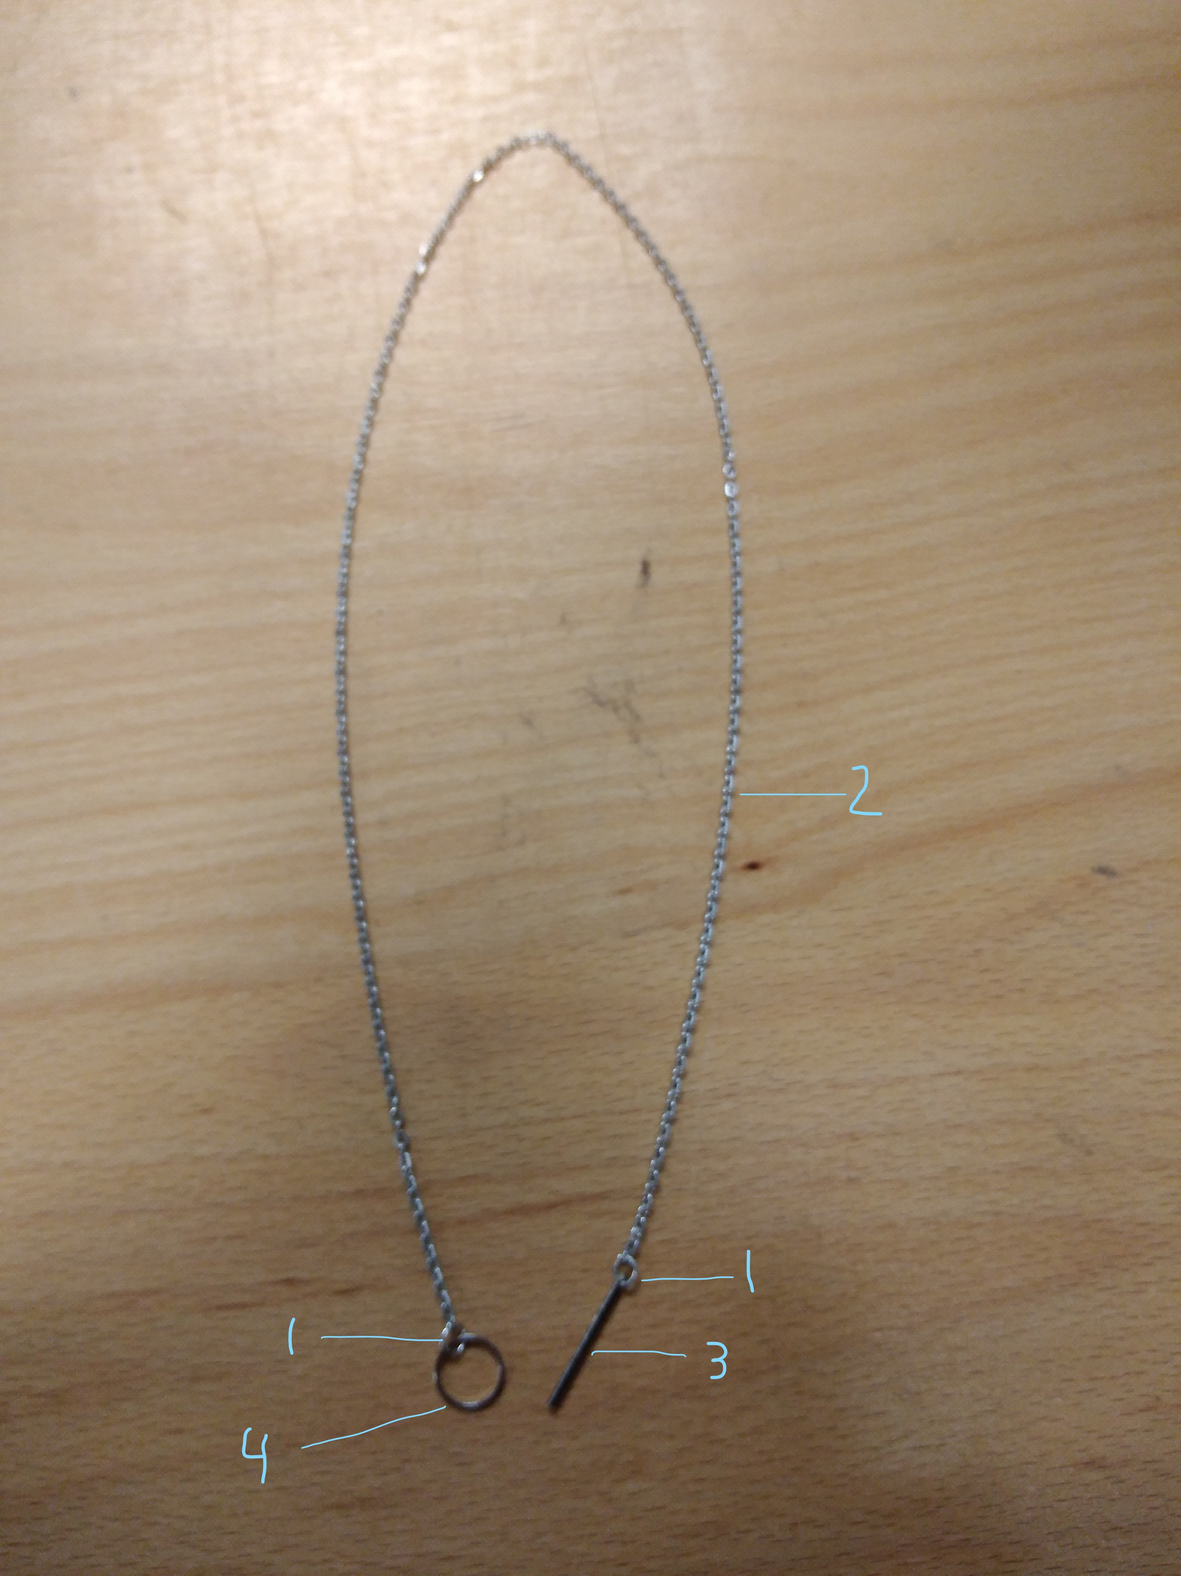
Necklace, divided into different parts:

#22580-1: Little rings (connection between main chain and closure)
#22580-2: Main chain
#22580-3: Rod (part of the closure)
#22580-4: Larger ring (part of the closure)

Please test as usual. In case you test routinely several parts, please report the test results of each determination in sample #22580-1, #22580-2, #22580-3 and #22580-4 according to the description in the picture above. Please understand that it is not obligated to test all four parts of the necklace but test the sample as it is done normally.
In case you do not test routinely the parts separately, please describe in the comments which parts of the necklace are used.

This report form continues on the next page.

Sample #22580-1: Little rings (connection between main chain and closure)
Determination | Unit | Reference  method *) | Actual method used *) | ’Unrounded’  result *) | Rounded  result cfr. used standard *)
Antimony as Sb, total | mg/kg
Arsenic as As, total | mg/kg
Cadmium as Cd, total | mg/kg
Chromium as Cr, total | mg/kg
Cobalt as Co, total | mg/kg
Copper as Cu, total | mg/kg
Lead as Pb, total | mg/kg
Manganese as Mn, total | mg/kg
Mercury as Hg, total | mg/kg
Nickel as Ni, total | mg/kg
Selenium as Se, total | mg/kg
Strontium as Sr, total | mg/kg
Tin as Sn, total | mg/kg
Zinc as Zn, total | mg/kg
Zirconium as Zr, total | mg/kg
*) Please see the letter of instructions before the start of the tests at www.kpmd.co.uk/sgs-iis-cts/

Comments:

This report form continues on the next page.

Sample #22580-2: Main chain
Determination | Unit | Reference  method *) | Actual method used *) | ’Unrounded’  result *) | Rounded  result cfr. used standard *)
Antimony as Sb, total | mg/kg
Arsenic as As, total | mg/kg
Cadmium as Cd, total | mg/kg
Chromium as Cr, total | mg/kg
Cobalt as Co, total | mg/kg
Copper as Cu, total | mg/kg
Lead as Pb, total | mg/kg
Manganese as Mn, total | mg/kg
Mercury as Hg, total | mg/kg
Nickel as Ni, total | mg/kg
Selenium as Se, total | mg/kg
Strontium as Sr, total | mg/kg
Tin as Sn, total | mg/kg
Zinc as Zn, total | mg/kg
Zirconium as Zr, total | mg/kg
*) Please see the letter of instructions before the start of the tests at www.kpmd.co.uk/sgs-iis-cts/

Comments:

This report form continues on the next page.

Sample #22580-3: Rod (part of the closure)
Determination | Unit | Reference  method *) | Actual method used *) | ’Unrounded’  result *) | Rounded  result cfr. used standard *)
Antimony as Sb, total | mg/kg
Arsenic as As, total | mg/kg
Cadmium as Cd, total | mg/kg
Chromium as Cr, total | mg/kg
Cobalt as Co, total | mg/kg
Copper as Cu, total | mg/kg
Lead as Pb, total | mg/kg
Manganese as Mn, total | mg/kg
Mercury as Hg, total | mg/kg
Nickel as Ni, total | mg/kg
Selenium as Se, total | mg/kg
Strontium as Sr, total | mg/kg
Tin as Sn, total | mg/kg
Zinc as Zn, total | mg/kg
Zirconium as Zr, total | mg/kg
*) Please see the letter of instructions before the start of the tests at www.kpmd.co.uk/sgs-iis-cts/

Comments:

This report form continues on the next page.

Sample #22580-4: Larger ring (part op the closure)
Determination | Unit | Reference  method *) | Actual method used *) | ’Unrounded’  result *) | Rounded  result cfr. used standard *)
Antimony as Sb, total | mg/kg
Arsenic as As, total | mg/kg
Cadmium as Cd, total | mg/kg
Chromium as Cr, total | mg/kg
Cobalt as Co, total | mg/kg
Copper as Cu, total | mg/kg
Lead as Pb, total | mg/kg
Manganese as Mn, total | mg/kg
Mercury as Hg, total | mg/kg
Nickel as Ni, total | mg/kg
Selenium as Se, total | mg/kg
Strontium as Sr, total | mg/kg
Tin as Sn, total | mg/kg
Zinc as Zn, total | mg/kg
Zirconium as Zr, total | mg/kg
*) Please see the letter of instructions before the start of the tests at www.kpmd.co.uk/sgs-iis-cts/

Comments:

Please see the next page for the Additional Questions.

Additional Questions

- Is your laboratory accredited in accordance with ISO/IEC17025 to determine the reported element(s)?

0 No

0 Yes

- How many grams of sample intake was used?

- Which acid was used for the digestion?

- What was the concentration (in %) of the acid solution?

- Which analyze technique was used to quantify the metals?

0 ICP-OES

0 ICP-AES

0 ICP-MS

0 UV-VIS

0 AAS

0 XRF

0 Other, please mention: _____________________________________________________________

6. Remarks on Additional Questions:

